Chapter 01
Overview of Financial Statement Analysis

Multiple Choice Questions
1. | Which of the following is likely to be the most informative source if you were interested in a company's business plan or strategy?  A. Auditor's letter  B. Management discussion and analysis  C. Proxy statement  D. Footnotes

2. | Which of the following would not be considered a source of financing?  A. Notes receivable  B. Common stockholders' equity  C. Retained earnings  D. Debentures

3. | Wilco Company reports the following:  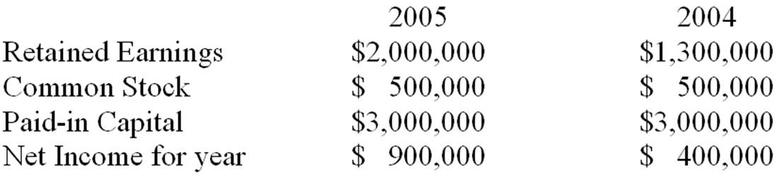  Dividend payout ratio for 2005 was:  A. 27%.  B. 12%.  C. 22.2%.  D. Not determinable

4. | If a company receives an unqualified audit opinion it means the auditors:  A. did not complete a full audit and therefore do not feel qualified to give an opinion on financial statements.  B. are providing assurance that the company will remain financially viable for at least the next year.  C. are providing assurance that the company's financial statements fairly present company's financial performance and position.  D. are providing assurance that the company's financial statements are free from misstatement, fraudulent accounting and fairly indicate future performance.

5. | The Management Discussion and Analysis Section of an annual report:  A. is required by the SEC.  B. is optional but normally included in the annual report.  C. is required by the SEC only if the company has suffered from unfavorable trends or there are significant uncertainty concerning liquidity of the company.  D. is required by the SEC only if they have a qualified audit opinion.

You are analyzing a large stable company. For the year ending 12/31/05 the company reported earnings of $58,900 and book value at the end of 2005 was $371,700. You expect earnings to grow at 5% a year in perpetuity, and the dividend payout ratio of 70% to continue. The company borrows at 8%, and has a cost of equity of 12%. The company has 25,000 shares outstanding.

6. | What is your estimate of price per share using the dividend discount model at 12/31/05?  A. $20.62  B. $21.65  C. $23.56  D. $24.74

7. | What is your estimate of price using the residual income valuation model at 12/31/05?  A. $20.62  B. $21.65  C. $23.56  D. $24.72

8. | Which of the following is not a common tool used in financial statement analysis?  A. Random walk analysis  B. Ratio analysis  C. Common-size statement analysis  D. Credit analysis

9. | A common-size income statement would typically be prepared by dividing:  A. all items on income statement in Year t by their corresponding value in Year t-1.  B. all items on income statement in Year t by their corresponding balance sheet accounts in Year t.  C. all items on income statement in Year t by net income in Year t-1.  D. all items on income statement in Year t by sales in Year t.

10. | When conducting comparative analysis by reviewing consecutive balance sheets:  A. all items on the balance sheet in Year t must be divided by their corresponding value in Year t-1 and subtract 1 to calculate the percentage change.  B. all items on the balance sheet in Year t-1 must be subtracted from their corresponding value in Year t to calculate the dollar change.  C. all items on the balance sheet in Year t must be divided by net income in Year t-1 to calculate the percentage change.  D. Both A and B are correct.

You have prepared a trend series for Company XYZ for three years, 2004-2006 inclusive, using 2004 as the base year. Below are selected data.
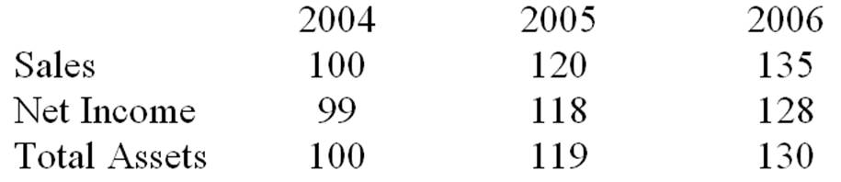

11. | From the above information, you can infer that:  A. rate of sales growth has decreased.  B. net income to sales (return on sales) is increasing over time.  C. asset turnover is decreasing over time.  D. None of the above

12. | Which of the following statements is incorrect?  A. Net income in 2006 increased by 29.29% compared to 2004.  B. XYZ's net income to sales (return on sales) is higher in 2006 as compared to 2004.  C. XYZ's net income to sales (return on sales) is lower in 2005 as compared to 2004.  D. Assets have increased over time.

13. | While determining the most profitable company from the given number of companies, which of the following would be the best indicator of relative profitability?  A. Highest net income  B. Highest retained earnings  C. Highest return on equity  D. Highest operating margin

14. | Which of the following statements concerning financial ratios is incorrect?  A. Accounting principles and methods used by a company will not affect financial ratios.  B. The informational value of a ratio in isolation is limited.  C. A ratio is one number expressed as a percentage or fraction of another number.  D. Calculation of financial ratios is not sufficient for a complete financial analysis of a company.

15. | Which of the following ratios is not generally considered to be helpful in assessing short-term liquidity?  A. Acid-test ratio  B. Current ratio  C. Days' to collect receivables  D. Total asset turnover

16. | Liquidity of a company is generally defined as a measure of:  A. the ability of a company to pay its employees in a timely manner.  B. the ability to pay interest and principal on all debt.  C. the ability to pay dividends.  D. the ability to pay current liabilities.

Following is some financial information of Dell Inc.
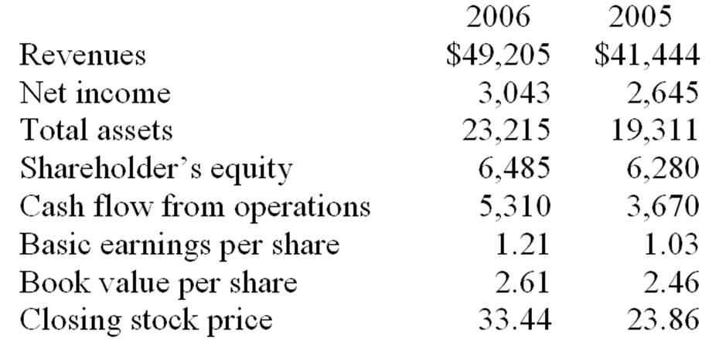

17. | What is Dell's profit margin for 2005?  A. 6.27%  B. 6.18%  C. 6.38%  D. 6.86%

18. | What is Dell's profit margin for 2006?  A. 6.27%  B. 6.18%  C. 6.38%  D. 6.86%

19. | What is Dell's price-to-earnings ratio for 2006?  A. 27.63  B. 12.81  C. 23.65  D. 9.70

20. | What is Dell's asset turnover for 2006?  A. 2.12  B. 3.58  C. 3.65  D. 2.31

21. | Given the following information, calculate the inventory turnover for ABC Co. for 2006 (pick closest number).  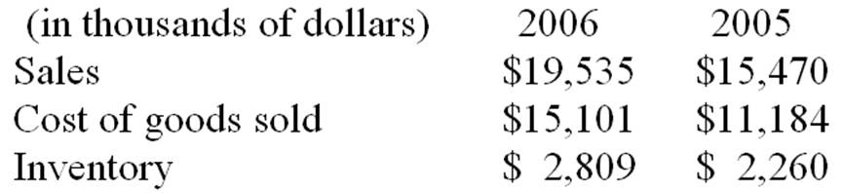  A. 8.96  B. 7.22  C. 6.93  D. 5.96

22. | You have been provided the following information about Wert Inc.  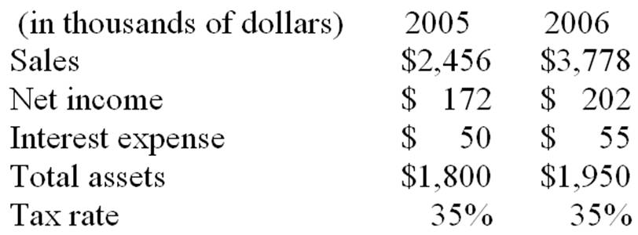  Return on assets for 2006 is:  A. 13.71%.  B. 12.68%.  C. 10.77%.  D. 13.21%.

You have been provided the following information about High Inc.
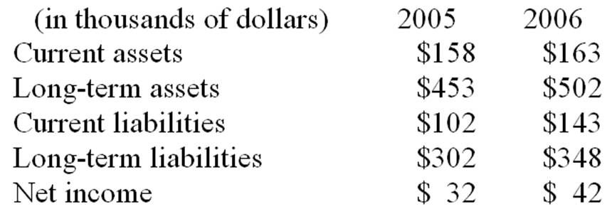

23. | Working capital for 2005 is:  A. $56,000.  B. $20,000.  C. $151,000.  D. $207,000.

24. | Owner's equity for 2006 is:  A. $20,000.  B. $154,000.  C. $174,000.  D. $207,000.

25. | Current ratio for 2005 is:  A. 1.55.  B. 1.51.  C. 1.50.  D. 1.14.

26. | Return on common equity for 2006 is:  A. 15.46%.  B. 24.14%.  C. 16.79%.  D. 22.04%.

27. | Which of the following statements is correct?  A. All other things being equal, the more efficiently a company utilizes its assets, the greater will be its return on investment.  B. All other things being equal, if return on equity increases, the return on assets must have also increased.  C. All other things being equal, if the number of days inventory held increases, the return on assets will increase.  D. All other things being equal, if the gross margin decreases, the inventory turnover must have increased.

28. | Which of the following statistics would be the most useful in determining the efficiency of a car rental company?  A. Inventory turnover  B. Number of employees per car rental  C. Average length of car rental  D. Number of days cars are rented as a percentage of number of days available for rent

29. | Which of the following ratios does not relate to market price of a company under analysis?  A. Price-to-earnings  B. Earnings yield  C. Price-to-book  D. Return on common equity

30. | The semistrong efficiency of market implies that:  A. stock prices fully reflect all inside information.  B. stock prices do not reflect information contained in past trading volume.  C. stock prices fully reflect all publicly available information.  D. stock prices fully reflect all information about future price changes.

31. | Which of the following statements is incorrect?  A. It is possible for some markets to be more efficient than others.  B. It is possible for markets to be efficient with respect to some information and inefficient with respect to other information.  C. The market is likely to be more efficient with respect to companies where there is greater analyst following.  D. The market is totally efficient with respect to companies providing regular dividends to investors.

32. | Which of the following ratios would be considered useful in assessing operating profitability?  A. Total debt to equity ratio  B. Acid-test ratio  C. Gross profit margin  D. Profit to equity ratio

33. | How much would you be prepared to pay for a $500 bond which comes due in 5 years and pays $80 interest annually assuming your required rate of return is 8% (pick closest answer)?  A. $740  B. $660  C. $608  D. $500

34. | Fluno Corporation has 1 million shares outstanding at the end of fiscal 2005. Its stock is trading at $15 per share. It issued $0.6 million in dividends, and had net income of $1 million in fiscal 2005. At the end of 2005, its total assets, liabilities, and retained earnings were $25 million, $15 million, and $7.5 million, respectively. Fluno's price-to-book ratio and dividend yield ratios for 2005 are:  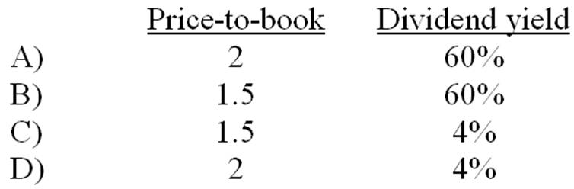  A. Option A  B. Option B  C. Option C  D. Option D

35. | Which of the following statements regarding the intrinsic value of a company is correct?  A. It can be calculated as book value plus the present value of future expected dividends, discounted at the cost of equity capital.  B. It can be calculated as present value of future expected dividends, discounted at the cost of debt.  C. It can be calculated as present value of future expected residual income, discounted at the cost of equity capital.  D. It can be calculated as book value plus the present value of future expected residual income, discounted at the cost of equity capital.

36. | Two otherwise equal companies have significantly different dividend payout ratios. Which of the following statements is most likely to be correct? The company with the higher dividend payout ratio:  A. will have a higher inventory turnover ratio.  B. will have a lower inventory turnover ratio.  C. will have a higher earnings retention ratio.  D. will have a lower earnings retention ratio.

37. | On January 1, 2005, Systil Corporation issues $50 million, 10-year bonds with a coupon rate of 10%. Interest is payable annually at the end of the year. If the required return on bonds of similar risk at January 1, 2006, is 8%, what will be the price of the bonds be at this date?  A. $56.71 million  B. $56.25 million  C. $44.24 million  D. $43.86 million

38. | Which of the following statements is most correct?  A. Technical analysis concerns itself with determining the intrinsic value of a stock.  B. Active investing is defined as buying and selling stock within six months.  C. Fundamental analysis attempts to value a company by examining the past prices patterns of a company's stock.  D. Individuals who apply active investment strategies primarily use technical analysis, fundamental analysis, or a combination.

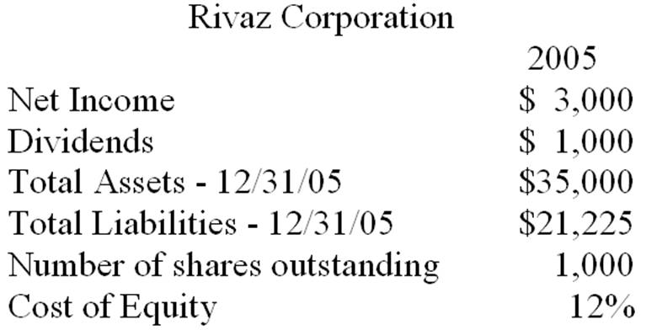

39. | Net income is expected to increase by 10% for the next year, and dividend payout ratio is expected to remain constant. After 2006, retained earnings are expected to decrease to zero. Using the residual income method what is the value per share of Rivaz stock as of 12/31/05?  A. $15.25  B. $15.16  C. $14.38  D. $13.77

40. | Using the dividend discount model, assuming dividends grow at 10% per year for the next two years and at 5% thereafter, what is the value per share of Rivaz Corporation at 12/31/05?  A. $16.61  B. $16.51  C. $16.42  D. $14.87

41. | Assuming total assets grew by $5,000 from 2004 to 2005, what is the return on assets of Rivaz Corporation for 2005?  A. 9.23%  B. 8.57%  C. 10.00%  D. 6.15%

42. | Which of the following statements is incorrect?  A. Current assets are expected to be converted into cash sooner than noncurrent assets.  B. Equity investors have unlimited downside exposure if the company declares bankruptcy.  C. Paid-in capital of company is not affected by the payment of dividends.  D. Retained earnings at the inception of a company equals zero.

43. | A company issues 12%, 10-year $1,000 bonds paying interest semiannually. Required return for bonds of this risk is 15%. At what price will the bond be sold (pick closest answer)?  A. $663  B. $849  C. $847  D. $894

44. | You wish to compare the performance of two companies. Which of the following statements is most likely to be incorrect?  A. If the companies operate in different industries, this will hinder comparability.  B. The use of different accounting methods will hinder comparability.  C. If the companies are of significantly different sizes, this will hinder comparability.  D. If companies have different auditors, this will hinder comparability.

45. | As of December 31, 2005, two otherwise identical companies in the same industry, East Company and West Company, have dividend payouts of 20% and 40%, respectively. Looking forward one year, which outcomes are least likely?  I. East Company requires debt financing.  II. West Company increases its dividend payout.  III. West Company's share price is twice that of East Company.  IV. East Company repurchases outstanding shares.  A. I and II  B. II and IV  C. I, II, and III  D. II, III, and IV

46. | Which of the following, if increased by 10%, results in a lower stock price?  A. Dividend payout  B. Earnings yield  C. Net profit margin  D. None of the above

47. | Which of the following is not an equity valuation model?  A. Residual income model  B. Dividend discount model  C. Free cash flow to equity model  D. Payback period model

True / False Questions
48. | Financial statement analysis is an exact science.  True False

49. | Theoretically, the value of a stock should equal the sum of the present value of future expected dividends, discounted at the cost of equity.  True False

50. | The value of a bond is equal to the sum of the present value of future expected interest and principal payments, discounted at the coupon rate.  True False

51. | Details of compensation paid to officers and directors can be found in proxy statements.  True False

52. | The statement of cash flows is separated into four parts: operating, investing, financing, and planning.  True False

53. | The SEC requires that Management Discussion and Analysis found in the annual report (10K) contains, among other things, a discussion about the company's liquidity, capital resources, and results of operations.  True False

54. | The explanatory notes (footnotes) accompanying the financial statements are generally of little value in aiding a financial analyst when interpreting the financial statements.  True False

55. | Two popular techniques of comparative analysis are year-to-year change analysis and index-number trend analysis.  True False

56. | Common-size statements are useful for intercompany comparisons.  True False

57. | In a common-size balance sheet, total assets are expressed as 100 percent.  True False

58. | In a common-size income statement, net income is expressed as 100 percent.  True False

59. | Inventory turnover is generally a more important ratio for a manufacturing firm than a service firm.  True False

60. | If a company has no liabilities, its return on equity will equal its return on assets.  True False

61. | The current ratio will always be greater than or equal to the acid test ratio.  True False

62. | The current ratio is used to evaluate a company's operating performance.  True False

63. | When calculating the return on assets, you should use average total assets.  True False

64. | Debt-to-equity ratio is a commonly used measure of liquidity.  True False

65. | Earnings yield is the reciprocal of the price-to-earnings ratio.  True False

66. | Dividend yield is defined as dividends divided by shareholders' equity.  True False

67. | A bank with a loan to a company is generally exposed to a greater risk than the shareholders of the company.  True False

68. | When comparing two companies, the company with the highest net income should normally have the highest stock price.  True False

69. | All other things being equal, the lower a company's cost of equity the higher will be its stock price.  True False

70. | A creditor's risk is said to be asymmetric because the downside is limited to the required interest payments.  True False

71. | The income statement is the only one of the four basic financial statements that does not contain balances at a specific point in time.  True False

72. | A capital-intensive company requires high cash turnover.  True False

73. | A security can be under- or overvalued, depending on the extent of an incorrect interpretation or faulty evaluation of available information by the aggregate market.  True False

74. | Prospective analysis is the forecasting of future payoffs—typically earnings, cash flows, or both.  True False

Essay Questions
75. | Information contained in Financial Statements  List ten different items you would expect to find in an average annual report to shareholders.

76. | Identify Industries  Below are selected ratios for three companies which operate in three different industries: Discount Retail Store, Drug, and Utility.  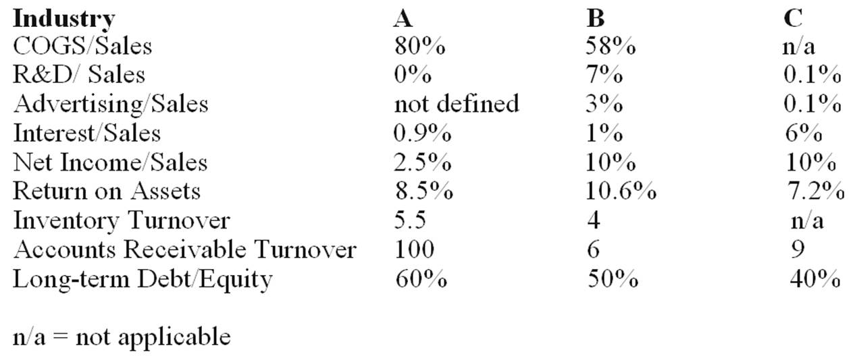  Identify which industry each of the companies A, B, and C operate in. Give two reasons for each of your selections.

77. | Balance Sheet Reconstruction  You want to prepare the balance sheet for Usher Inc. as of December 31, 2005. Use the following information. All information pertains to fiscal 2005 unless otherwise stated.  • Retained earnings at December 31, 2004 is $234,000  • Sales (all credit sales) are $2.5 million  • Days to sell inventory is 20  • Cash on hand is 1% of sales  • All sales are paid 30 days after purchase  • Noncurrent assets are $1 million  • Long-term debt to equity ratio is 1  • All liabilities, other than long-term debt, are short-term liabilities  • 20,000 shares outstanding issued at $10 in 2004  • No dividends are paid  • Gross margin is 40%  • Net profit margin is 8%  • Assume there are 360 days in the year

78. | Valuation of Equity  Assets and liabilities at the end of 2005 for Tripod Inc. are $4,970 and $2,220 respectively. Net income and dividends for fiscal 2005 were $500 and $200, respectively. Tripod has 100 shares outstanding as of 12/31/05.  Net income is expected to grow at 10% for the next three years (2006-2008). The dividend payout ratio is expected to remain at 2005 level for next three years. After 2005 abnormal earnings are expected to be zero. Cost of debt is 8% and cost of equity is 15%.  What would you be prepared to pay per share for Tripod stock at the end of fiscal 2005, using the accounting based equity valuation formula?

79. | Equity Valuation  In the table below is selected information for Sprigue Company.  All figures are in thousands and represent expectations of the future.  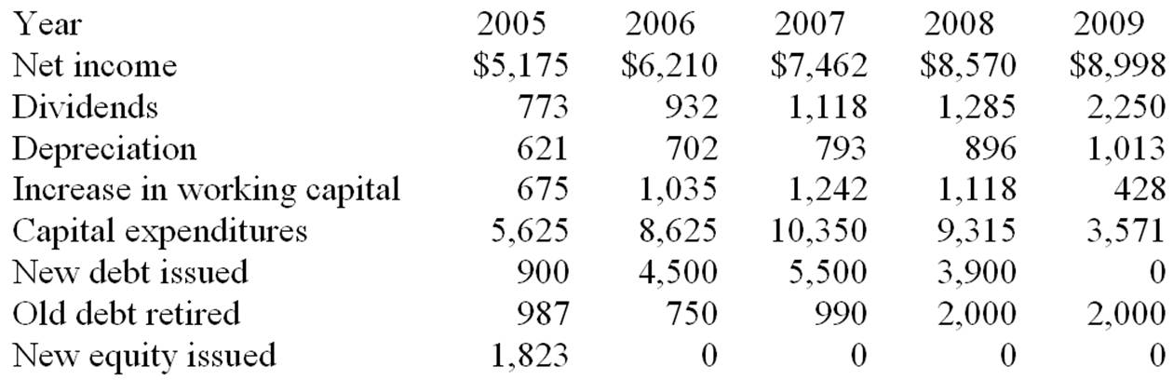  a. Calculate the expected free cash flow to equity for the years 2005 to 2009.  b. Explain the expected changes in debt levels over the five years.

80. | Equity Valuation  A friend tells you that you should buy Leclerc Company stock as it is a "great deal." It is January 1, 2006 and the stock is trading at $25 per share. You obtain the financial statements for Leclerc and determine the following:  1. Book value is $12 per share as of December 31, 2005.  2. Earnings for 2005 were $4.0 per share.  3. Earnings are expected to grow at 20% for the next four years.  4. Dividend payout is 40%.  5. Residual income is expected to be zero from 2007 onwards.  6. Cost of equity capital is 15%.  Determine, using the residual income method, whether you should buy Leclerc stock as of January 1, 2006.

81. | Valuation of Bonds  a. It is January 1, 2006 and you are considering buying $20,000 of Hilever Company's 10% bonds, which come due on December 31, 2015. The bonds pay interest semiannually on June 30 and December 31 of each year. The prevailing interest rate on bonds of similar risk is 12%. How much would you be prepared to pay for the bond?  b. If coupon rate was 12% on these bonds, how much would you be prepared to pay?  c. If the coupon rate was 10% and the bonds were convertible into common equity (5 shares for every $1,000 face value coupon bond), and common stock is currently trading at $11 per share would this change your answer to part a? Why?

Chapter 01 Overview of Financial Statement Analysis Answer Key

Multiple Choice Questions
1. | Which of the following is likely to be the most informative source if you were interested in a company's business plan or strategy?  A. Auditor's letter  B. Management discussion and analysis  C. Proxy statement  D. Footnotes

2. | Which of the following would not be considered a source of financing?  A. Notes receivable  B. Common stockholders' equity  C. Retained earnings  D. Debentures

3. | Wilco Company reports the following:  Dividend payout ratio for 2005 was:  A. 27%.  B. 12%.  C. 22.2%.  D. Not determinable

4. | If a company receives an unqualified audit opinion it means the auditors:  A. did not complete a full audit and therefore do not feel qualified to give an opinion on financial statements.  B. are providing assurance that the company will remain financially viable for at least the next year.  C. are providing assurance that the company's financial statements fairly present company's financial performance and position.  D. are providing assurance that the company's financial statements are free from misstatement, fraudulent accounting and fairly indicate future performance.

5. | The Management Discussion and Analysis Section of an annual report:  A. is required by the SEC.  B. is optional but normally included in the annual report.  C. is required by the SEC only if the company has suffered from unfavorable trends or there are significant uncertainty concerning liquidity of the company.  D. is required by the SEC only if they have a qualified audit opinion.

You are analyzing a large stable company. For the year ending 12/31/05 the company reported earnings of $58,900 and book value at the end of 2005 was $371,700. You expect earnings to grow at 5% a year in perpetuity, and the dividend payout ratio of 70% to continue. The company borrows at 8%, and has a cost of equity of 12%. The company has 25,000 shares outstanding.

6. | What is your estimate of price per share using the dividend discount model at 12/31/05?  A. $20.62  B. $21.65  C. $23.56  D. $24.74  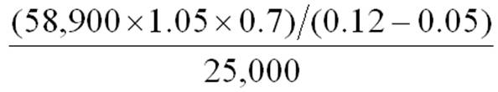

7. | What is your estimate of price using the residual income valuation model at 12/31/05?  A. $20.62  B. $21.65  C. $23.56  D. $24.72  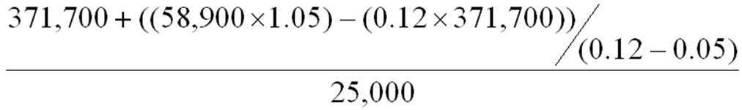

8. | Which of the following is not a common tool used in financial statement analysis?  A. Random walk analysis  B. Ratio analysis  C. Common-size statement analysis  D. Credit analysis

9. | A common-size income statement would typically be prepared by dividing:  A. all items on income statement in Year t by their corresponding value in Year t-1.  B. all items on income statement in Year t by their corresponding balance sheet accounts in Year t.  C. all items on income statement in Year t by net income in Year t-1.  D. all items on income statement in Year t by sales in Year t.

10. | When conducting comparative analysis by reviewing consecutive balance sheets:  A. all items on the balance sheet in Year t must be divided by their corresponding value in Year t-1 and subtract 1 to calculate the percentage change.  B. all items on the balance sheet in Year t-1 must be subtracted from their corresponding value in Year t to calculate the dollar change.  C. all items on the balance sheet in Year t must be divided by net income in Year t-1 to calculate the percentage change.  D. Both A and B are correct.

You have prepared a trend series for Company XYZ for three years, 2004-2006 inclusive, using 2004 as the base year. Below are selected data.

11. | From the above information, you can infer that:  A. rate of sales growth has decreased.  B. net income to sales (return on sales) is increasing over time.  C. asset turnover is decreasing over time.  D. None of the above

12. | Which of the following statements is incorrect?  A. Net income in 2006 increased by 29.29% compared to 2004.  B. XYZ's net income to sales (return on sales) is higher in 2006 as compared to 2004.  C. XYZ's net income to sales (return on sales) is lower in 2005 as compared to 2004.  D. Assets have increased over time.

13. | While determining the most profitable company from the given number of companies, which of the following would be the best indicator of relative profitability?  A. Highest net income  B. Highest retained earnings  C. Highest return on equity  D. Highest operating margin

14. | Which of the following statements concerning financial ratios is incorrect?  A. Accounting principles and methods used by a company will not affect financial ratios.  B. The informational value of a ratio in isolation is limited.  C. A ratio is one number expressed as a percentage or fraction of another number.  D. Calculation of financial ratios is not sufficient for a complete financial analysis of a company.

15. | Which of the following ratios is not generally considered to be helpful in assessing short-term liquidity?  A. Acid-test ratio  B. Current ratio  C. Days' to collect receivables  D. Total asset turnover

16. | Liquidity of a company is generally defined as a measure of:  A. the ability of a company to pay its employees in a timely manner.  B. the ability to pay interest and principal on all debt.  C. the ability to pay dividends.  D. the ability to pay current liabilities.

Following is some financial information of Dell Inc.

17. | What is Dell's profit margin for 2005?  A. 6.27%  B. 6.18%  C. 6.38%  D. 6.86%

18. | What is Dell's profit margin for 2006?  A. 6.27%  B. 6.18%  C. 6.38%  D. 6.86%

19. | What is Dell's price-to-earnings ratio for 2006?  A. 27.63  B. 12.81  C. 23.65  D. 9.70

20. | What is Dell's asset turnover for 2006?  A. 2.12  B. 3.58  C. 3.65  D. 2.31

21. | Given the following information, calculate the inventory turnover for ABC Co. for 2006 (pick closest number).  A. 8.96  B. 7.22  C. 6.93  D. 5.96

22. | You have been provided the following information about Wert Inc.  Return on assets for 2006 is:  A. 13.71%.  B. 12.68%.  C. 10.77%.  D. 13.21%.

You have been provided the following information about High Inc.

23. | Working capital for 2005 is:  A. $56,000.  B. $20,000.  C. $151,000.  D. $207,000.

24. | Owner's equity for 2006 is:  A. $20,000.  B. $154,000.  C. $174,000.  D. $207,000.

25. | Current ratio for 2005 is:  A. 1.55.  B. 1.51.  C. 1.50.  D. 1.14.

26. | Return on common equity for 2006 is:  A. 15.46%.  B. 24.14%.  C. 16.79%.  D. 22.04%.

27. | Which of the following statements is correct?  A. All other things being equal, the more efficiently a company utilizes its assets, the greater will be its return on investment.  B. All other things being equal, if return on equity increases, the return on assets must have also increased.  C. All other things being equal, if the number of days inventory held increases, the return on assets will increase.  D. All other things being equal, if the gross margin decreases, the inventory turnover must have increased.

28. | Which of the following statistics would be the most useful in determining the efficiency of a car rental company?  A. Inventory turnover  B. Number of employees per car rental  C. Average length of car rental  D. Number of days cars are rented as a percentage of number of days available for rent

29. | Which of the following ratios does not relate to market price of a company under analysis?  A. Price-to-earnings  B. Earnings yield  C. Price-to-book  D. Return on common equity

30. | The semistrong efficiency of market implies that:  A. stock prices fully reflect all inside information.  B. stock prices do not reflect information contained in past trading volume.  C. stock prices fully reflect all publicly available information.  D. stock prices fully reflect all information about future price changes.

31. | Which of the following statements is incorrect?  A. It is possible for some markets to be more efficient than others.  B. It is possible for markets to be efficient with respect to some information and inefficient with respect to other information.  C. The market is likely to be more efficient with respect to companies where there is greater analyst following.  D. The market is totally efficient with respect to companies providing regular dividends to investors.

32. | Which of the following ratios would be considered useful in assessing operating profitability?  A. Total debt to equity ratio  B. Acid-test ratio  C. Gross profit margin  D. Profit to equity ratio

33. | How much would you be prepared to pay for a $500 bond which comes due in 5 years and pays $80 interest annually assuming your required rate of return is 8% (pick closest answer)?  A. $740  B. $660  C. $608  D. $500

34. | Fluno Corporation has 1 million shares outstanding at the end of fiscal 2005. Its stock is trading at $15 per share. It issued $0.6 million in dividends, and had net income of $1 million in fiscal 2005. At the end of 2005, its total assets, liabilities, and retained earnings were $25 million, $15 million, and $7.5 million, respectively. Fluno's price-to-book ratio and dividend yield ratios for 2005 are:  A. Option A  B. Option B  C. Option C  D. Option D

35. | Which of the following statements regarding the intrinsic value of a company is correct?  A. It can be calculated as book value plus the present value of future expected dividends, discounted at the cost of equity capital.  B. It can be calculated as present value of future expected dividends, discounted at the cost of debt.  C. It can be calculated as present value of future expected residual income, discounted at the cost of equity capital.  D. It can be calculated as book value plus the present value of future expected residual income, discounted at the cost of equity capital.

36. | Two otherwise equal companies have significantly different dividend payout ratios. Which of the following statements is most likely to be correct? The company with the higher dividend payout ratio:  A. will have a higher inventory turnover ratio.  B. will have a lower inventory turnover ratio.  C. will have a higher earnings retention ratio.  D. will have a lower earnings retention ratio.

37. | On January 1, 2005, Systil Corporation issues $50 million, 10-year bonds with a coupon rate of 10%. Interest is payable annually at the end of the year. If the required return on bonds of similar risk at January 1, 2006, is 8%, what will be the price of the bonds be at this date?  A. $56.71 million  B. $56.25 million  C. $44.24 million  D. $43.86 million

38. | Which of the following statements is most correct?  A. Technical analysis concerns itself with determining the intrinsic value of a stock.  B. Active investing is defined as buying and selling stock within six months.  C. Fundamental analysis attempts to value a company by examining the past prices patterns of a company's stock.  D. Individuals who apply active investment strategies primarily use technical analysis, fundamental analysis, or a combination.

39. | Net income is expected to increase by 10% for the next year, and dividend payout ratio is expected to remain constant. After 2006, retained earnings are expected to decrease to zero. Using the residual income method what is the value per share of Rivaz stock as of 12/31/05?  A. $15.25  B. $15.16  C. $14.38  D. $13.77

40. | Using the dividend discount model, assuming dividends grow at 10% per year for the next two years and at 5% thereafter, what is the value per share of Rivaz Corporation at 12/31/05?  A. $16.61  B. $16.51  C. $16.42  D. $14.87

41. | Assuming total assets grew by $5,000 from 2004 to 2005, what is the return on assets of Rivaz Corporation for 2005?  A. 9.23%  B. 8.57%  C. 10.00%  D. 6.15%

42. | Which of the following statements is incorrect?  A. Current assets are expected to be converted into cash sooner than noncurrent assets.  B. Equity investors have unlimited downside exposure if the company declares bankruptcy.  C. Paid-in capital of company is not affected by the payment of dividends.  D. Retained earnings at the inception of a company equals zero.

43. | A company issues 12%, 10-year $1,000 bonds paying interest semiannually. Required return for bonds of this risk is 15%. At what price will the bond be sold (pick closest answer)?  A. $663  B. $849  C. $847  D. $894  If the students calculate this assuming annual payments (N = 10, PMT = 120, I = 15%), they will get answer B, not C. The correct solution is calculated with N = 20, PMT = 60 and I = 7.5%. You may wish to award half marks for answer B.

44. | You wish to compare the performance of two companies. Which of the following statements is most likely to be incorrect?  A. If the companies operate in different industries, this will hinder comparability.  B. The use of different accounting methods will hinder comparability.  C. If the companies are of significantly different sizes, this will hinder comparability.  D. If companies have different auditors, this will hinder comparability.

45. | As of December 31, 2005, two otherwise identical companies in the same industry, East Company and West Company, have dividend payouts of 20% and 40%, respectively. Looking forward one year, which outcomes are least likely?  I. East Company requires debt financing.  II. West Company increases its dividend payout.  III. West Company's share price is twice that of East Company.  IV. East Company repurchases outstanding shares.  A. I and II  B. II and IV  C. I, II, and III  D. II, III, and IV

46. | Which of the following, if increased by 10%, results in a lower stock price?  A. Dividend payout  B. Earnings yield  C. Net profit margin  D. None of the above

47. | Which of the following is not an equity valuation model?  A. Residual income model  B. Dividend discount model  C. Free cash flow to equity model  D. Payback period model

True / False Questions
48. | Financial statement analysis is an exact science.  FALSE

49. | Theoretically, the value of a stock should equal the sum of the present value of future expected dividends, discounted at the cost of equity.  TRUE

50. | The value of a bond is equal to the sum of the present value of future expected interest and principal payments, discounted at the coupon rate.  FALSE

51. | Details of compensation paid to officers and directors can be found in proxy statements.  TRUE

52. | The statement of cash flows is separated into four parts: operating, investing, financing, and planning.  FALSE

53. | The SEC requires that Management Discussion and Analysis found in the annual report (10K) contains, among other things, a discussion about the company's liquidity, capital resources, and results of operations.  TRUE

54. | The explanatory notes (footnotes) accompanying the financial statements are generally of little value in aiding a financial analyst when interpreting the financial statements.  FALSE

55. | Two popular techniques of comparative analysis are year-to-year change analysis and index-number trend analysis.  TRUE

56. | Common-size statements are useful for intercompany comparisons.  TRUE

57. | In a common-size balance sheet, total assets are expressed as 100 percent.  TRUE

58. | In a common-size income statement, net income is expressed as 100 percent.  FALSE

59. | Inventory turnover is generally a more important ratio for a manufacturing firm than a service firm.  TRUE

60. | If a company has no liabilities, its return on equity will equal its return on assets.  TRUE

61. | The current ratio will always be greater than or equal to the acid test ratio.  TRUE

62. | The current ratio is used to evaluate a company's operating performance.  FALSE

63. | When calculating the return on assets, you should use average total assets.  TRUE

64. | Debt-to-equity ratio is a commonly used measure of liquidity.  FALSE

65. | Earnings yield is the reciprocal of the price-to-earnings ratio.  TRUE

66. | Dividend yield is defined as dividends divided by shareholders' equity.  FALSE

67. | A bank with a loan to a company is generally exposed to a greater risk than the shareholders of the company.  FALSE

68. | When comparing two companies, the company with the highest net income should normally have the highest stock price.  FALSE

69. | All other things being equal, the lower a company's cost of equity the higher will be its stock price.  TRUE

70. | A creditor's risk is said to be asymmetric because the downside is limited to the required interest payments.  TRUE

71. | The income statement is the only one of the four basic financial statements that does not contain balances at a specific point in time.  FALSE

72. | A capital-intensive company requires high cash turnover.  FALSE

73. | A security can be under- or overvalued, depending on the extent of an incorrect interpretation or faulty evaluation of available information by the aggregate market.  TRUE

74. | Prospective analysis is the forecasting of future payoffs—typically earnings, cash flows, or both.  TRUE

Essay Questions
75. | Information contained in Financial Statements  List ten different items you would expect to find in an average annual report to shareholders.  • Income statement  • Balance sheet  • Statement of cash flows  • Statement of shareholders' equity  • Footnotes  • Auditor report  • Letter to shareholders  • Business segment data  • Management's Discussion and Analysis  • Information on stock option plans  • Information on marketable securities  • Lists of directors and officers of company  • List of members of board of directors

76. | Identify Industries  Below are selected ratios for three companies which operate in three different industries: Discount Retail Store, Drug, and Utility.  Identify which industry each of the companies A, B, and C operate in. Give two reasons for each of your selections.  Company A is the discount retail store as evidenced by:  • very low return on sales.  • highest inventory turnover.  • highest accounts receivable turnover.  Company B is the drug manufacturer as evidenced by:  • high R&D expenditure.  • high advertising expenditure.  Company C is the utility as evidenced by:  • low asset turnover.  • very low advertising expenditures.  • undefined inventory turnover.

77. | Balance Sheet Reconstruction  You want to prepare the balance sheet for Usher Inc. as of December 31, 2005. Use the following information. All information pertains to fiscal 2005 unless otherwise stated.  • Retained earnings at December 31, 2004 is $234,000  • Sales (all credit sales) are $2.5 million  • Days to sell inventory is 20  • Cash on hand is 1% of sales  • All sales are paid 30 days after purchase  • Noncurrent assets are $1 million  • Long-term debt to equity ratio is 1  • All liabilities, other than long-term debt, are short-term liabilities  • 20,000 shares outstanding issued at $10 in 2004  • No dividends are paid  • Gross margin is 40%  • Net profit margin is 8%  • Assume there are 360 days in the year  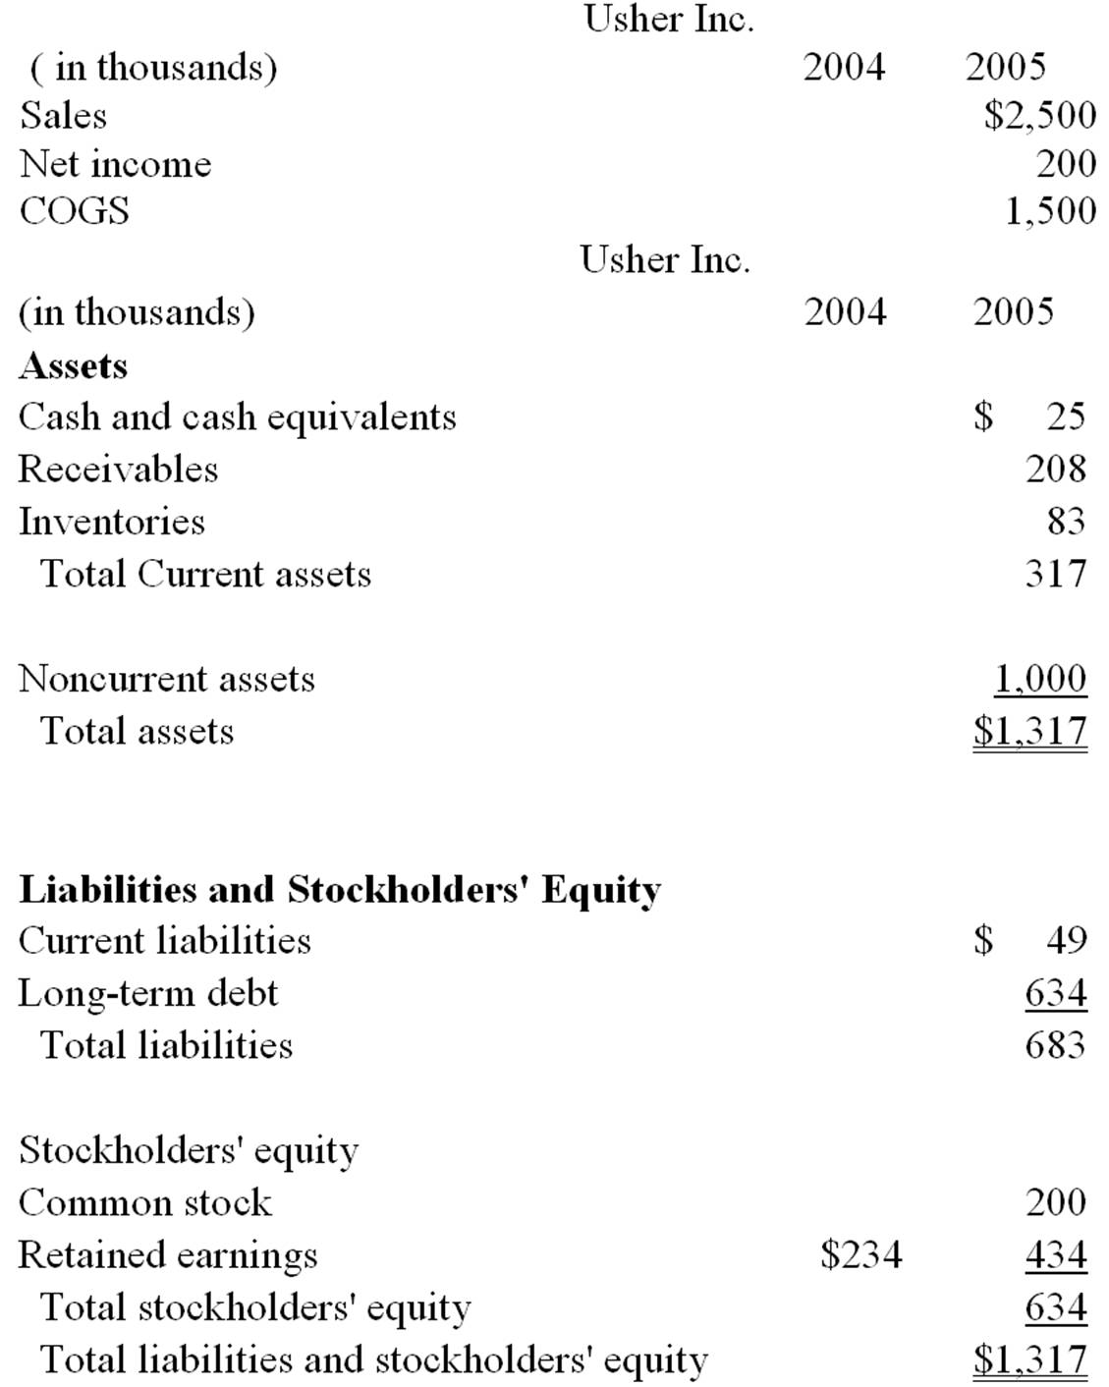

78. | Valuation of Equity  Assets and liabilities at the end of 2005 for Tripod Inc. are $4,970 and $2,220 respectively. Net income and dividends for fiscal 2005 were $500 and $200, respectively. Tripod has 100 shares outstanding as of 12/31/05.  Net income is expected to grow at 10% for the next three years (2006-2008). The dividend payout ratio is expected to remain at 2005 level for next three years. After 2005 abnormal earnings are expected to be zero. Cost of debt is 8% and cost of equity is 15%.  What would you be prepared to pay per share for Tripod stock at the end of fiscal 2005, using the accounting based equity valuation formula?  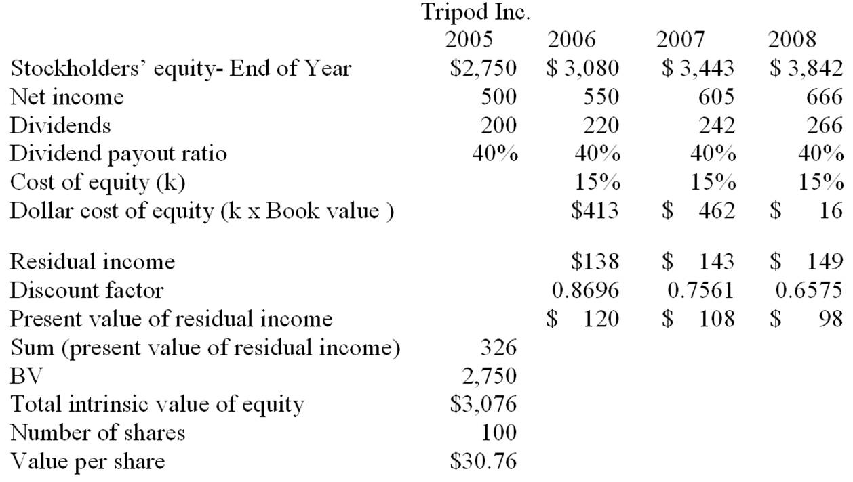

79. | Equity Valuation  In the table below is selected information for Sprigue Company.  All figures are in thousands and represent expectations of the future.  a. Calculate the expected free cash flow to equity for the years 2005 to 2009.  b. Explain the expected changes in debt levels over the five years.  a.  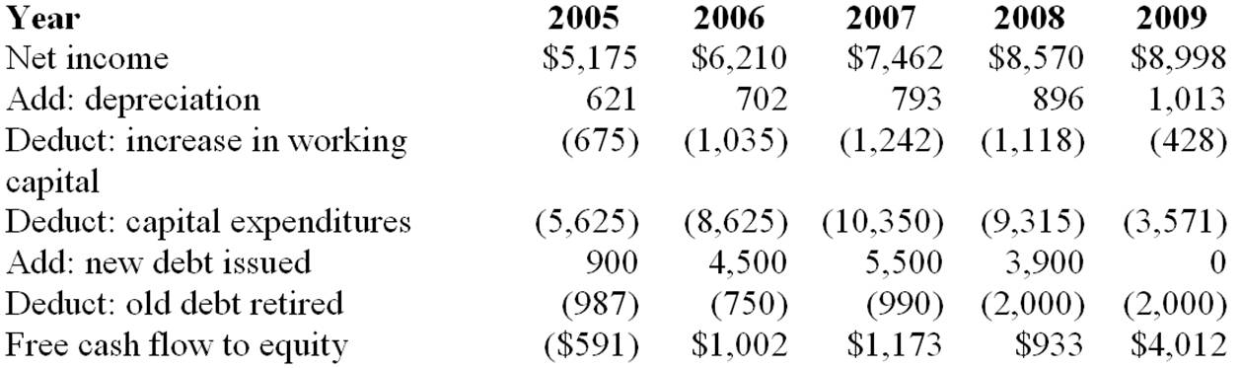  b. This company is clearly in a growth phase from 2005-2009 as evidenced by the growth in net income and the net new investment in capital assets and working capital. During high growth phases a company will often find that it needs additional financing to fund the growth. This company is expecting to fund this growth with equity in 2005 and debt in 2006-2009. After 2006 when the growth slows down the company starts to generate positive cash flows from operations and has no need of additional external financing.

80. | Equity Valuation  A friend tells you that you should buy Leclerc Company stock as it is a "great deal." It is January 1, 2006 and the stock is trading at $25 per share. You obtain the financial statements for Leclerc and determine the following:  1. Book value is $12 per share as of December 31, 2005.  2. Earnings for 2005 were $4.0 per share.  3. Earnings are expected to grow at 20% for the next four years.  4. Dividend payout is 40%.  5. Residual income is expected to be zero from 2007 onwards.  6. Cost of equity capital is 15%.  Determine, using the residual income method, whether you should buy Leclerc stock as of January 1, 2006.  You should not buy Leclerc stock as the intrinsic value is below the current market price.  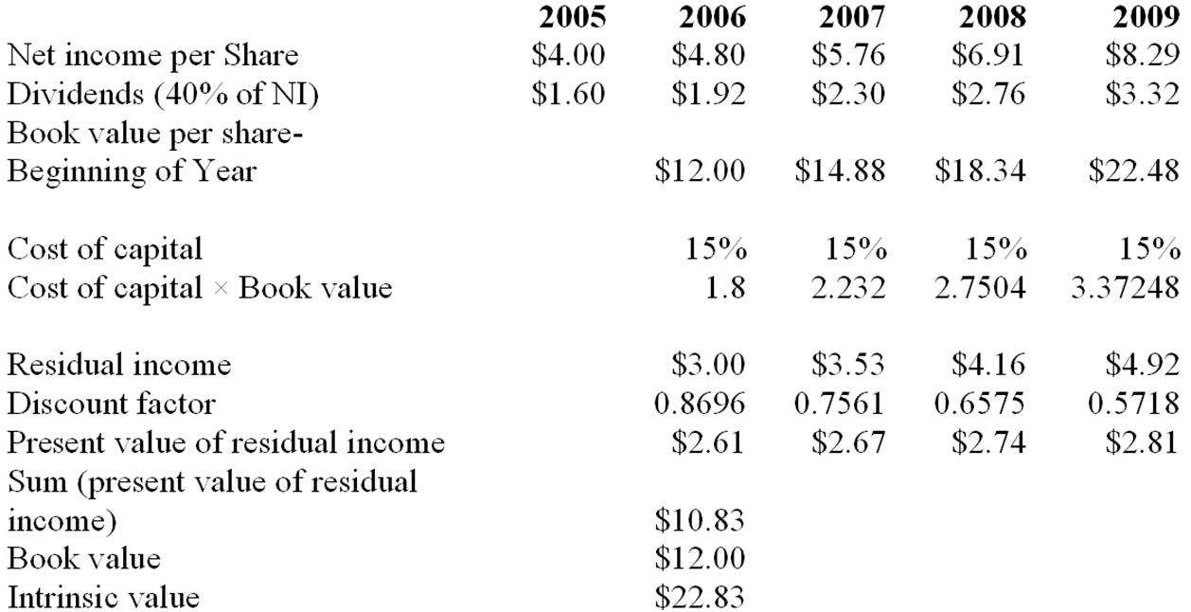

81. | Valuation of Bonds  a. It is January 1, 2006 and you are considering buying $20,000 of Hilever Company's 10% bonds, which come due on December 31, 2015. The bonds pay interest semiannually on June 30 and December 31 of each year. The prevailing interest rate on bonds of similar risk is 12%. How much would you be prepared to pay for the bond?  b. If coupon rate was 12% on these bonds, how much would you be prepared to pay?  c. If the coupon rate was 10% and the bonds were convertible into common equity (5 shares for every $1,000 face value coupon bond), and common stock is currently trading at $11 per share would this change your answer to part a? Why?  a. Semiannual interest = ($20,000 × 0.10 × 0.5) = $1,000  Semiannual interest will be received for 20 periods  Discount rate = 6% (semiannual)  Principal of $20,000, discounted for 20 periods at 6%  Value of bond = $17,706  b. $20,000 (coupon rate equals required return so bond will sell at par)  c. Yes. Even though you would not want to convert currently at $11 per share, the conversion feature is equivalent to owning an out-of-the-money stock option and has some positive value. Therefore, you would be prepared to pay more than in part a.

